Decontaminated water discharge and dilution from the Fukushima accident into the Pacific Ocean
Sheng Kao
Electrical and Computer Engineering Univ. of Illinois at Urbana-Champaign Urbana, United States shengk2@illinois.edu

Magdi Ragheb
Nuclear, Plasma and Radiological Engineering Univ. of Illinois at Urbana-Champaign Urbana, United States mragheb@illinois.edu,http://www.mragheb.com

Abstract—Ever since the tsunami accident 2011, Fukushima nuclear power plant has been pumping sea water and under- ground water to cool the leaking radioactive fuels. TEPCO had develop a system to decontaminated the cooling water, named ALPS. The system treated and stored the waste water near the nuclear site. On 13 April 2021, Japanese government announced to release treated radioactive waste water into the sea in two years because the storage unit is going to be full. TEPCO claims that the ALPS treated water meet the regulation of releasing. However, the claim is not fully truth. Japanese government needs to provide more detail regulation or other disposal plans in order to not cause irreversible pollution to the earth.
Index Terms—ALPS, Fukushima nuclear accident, Nuclear waste water, Tritium
I. INTRODUCTION
On 13 April 2021, Japanese government announced to release treated radioactive waste water into the Pacific Ocean in 2023. [1] In fact, the Japanese government had been trying to deal with the problem of radioactive waste water from the 2011 Fukushima tsunami incident for a decade. Since the tsunami, the Fukushima nuclear power plant had been suffered with a leaking problem in the cooling water facility. The contaminated water was treated and stored the in water tanks after the tsunami. However, the tanks are about to hit their full capacity in the end of 2022. The Japanese government claimed that the Tokyo Electric Power Company Holdings, Inc(TEPCO) had developed a technology to treat the radioactive waste water called ”Advanced Liquid Processing System or ALPS”. The system can remove most of the radioactive elements in the water, but some still remain. The most controversial one remaining is tritium which is radioactive. Nevertheless, TEPCO claims that the treated water fits the regulation of the Japanese Nuclear Regulatory Commission standard. However, the general public and the Greenpeace foundation are still concerning about how releasing this water into the sea will affect the ocean environment. According to Greenpeace, ”(Japanese government) Rather than using the best available technology to minimize radiation hazards by storing and processing the water over the long term, they have opted for the cheapest option.” [2]
However, storing the processed water may still not be the best solution. It could face the chance of the storage unit weary and caused leaking problem as long as the power plant is not fully evacuated. For example, in 2012, one year after the accident, the water tanks started leaking due to the rust at the welding connected part. Although TEPCO found out and fixed the tanks, the following year, radioactivity was still leaking into the ocean due to unclear reasons. The company built a 2,400-foot-long steel and concrete wall between the site and ocean to prevent further pollution of the ocean. Also, the company decided to build a ice wall underground to prevent the radioactive water leak through underground water layer. However, in September 2015, Typhonno Etau hit Japan and overwhelmed the drainage pumps at the Fukushima nuclear plant. As the result, hundreds of metric tons of radioactive water entered the ocean. [3] Therefore, for Japanese govern- ment, the urgent priority is to address a feasible, safe, and immediate solution to clean up the Fukushima Daiichi nuclear power plant.

II. FUKUSHIMA EARTHQUAKE AND TSUNAMI STATION BLACKOUT ACCIDENT

The Fukushima Daiichi nuclear power plant has six sepa- rated boiling water reactors(BWR) designed by General elec- tric managed by the TEPCO, as shown in Fig.1. These reactors were designed to generate 4.7GWe of power of electricity. The power plant is damaged by earthquake and Tsunami in 2011. The accident affects about 170,000 civilians in the 30-km evacuation zone surrounding the plant. In the following year, units 1 to 4 were shut down for the damaged cannot be restored. Although unit 5 and 6 were not damaged in the accident, they were also being shut down in 2014. Thus, the whole power plant is disabled. [4]
The 2011 To ̄hoku earthquake and tsunami occurred on 11 March 2011. The Magnitude scale of 9.0 earthquake was mea- sured near the cost of Honshu. At the day of the earthquake happened, only the reactor 1, 2, 3 were operating, and the unit 4,5,6 were shut off for scheduled investigation. The earthquake caused the operating units to shut down automatically. The earthquake also caused a fault of the electrical power, but the emergency diesel generators soon started up to sustain the power that runs the water cooling system. Fifty minutes after the earthquake, the tsunami hit the power plant. The 14-meter- height wave submerged the turbine building and flushed into the basement where the diesel generators were, as shown in Fig. 2.

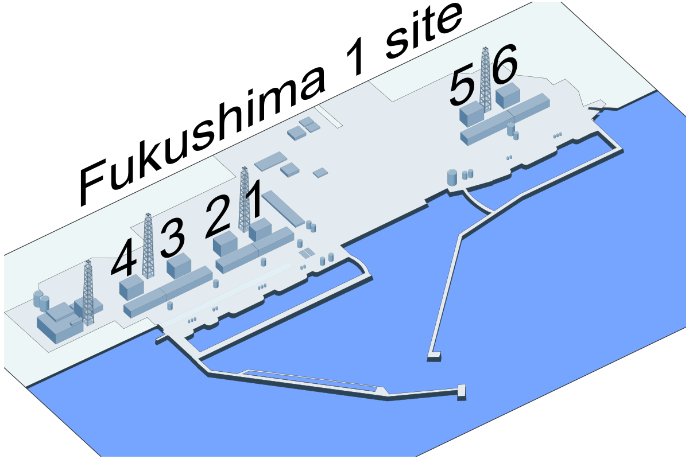

Fig. 1. Fukushima Nuclear power plants 1975 [5]

Subsequently, the pump in the cooling water system ceased functioning and led to meltdowns from the decay heat of the rods in Reactors unit 1, 2, and 3. Sixteen hour into the accident, the uranium fuel rods debris melt through the bottom of the outer containment vessels. The high temperature evaporated the water built up the pressure in the vessel. The vessels in Unit 1 reactor were exploded, and Unit 2 and 3 were damaged and started leaking radioactive fuel into the water. The hydrogen produced by the leaking fuel soon filled up the Unit 1 to 4, and caused a hydrogen explosion. The explosion destroyed the power plants buildings and the facilities near it, which caused a massive leakage of radioactive element into the air and the ocean. According to an estimate by the United Nations Scientific Committee on the Effects of Atomic Radiation, the accident released about 100-500 PBq of iodine and 6-20 PBq of cesium 137 into the atmosphere, and 10-20 PBq of iodine and 3-6 PBq of cesium into the ocean. [6]
The following months, more water kept been pumping into the power plant to cool down the remaining fuel rods. TEPCO used remote control robot to investigate and monitor inside the power plant. The clean-up team used special material to cover up the radioactive debris and collected the contaminated water. The following years Japanese government spent 47 billion Japanese dollars building up relative equipment to prevent further leakage of the radioactive water into the atmosphere, underground water and ocean.

III. ADVANCED LIQUID PROCESSING SYSTEM(ALPS)

In October 2012, TEPCO developed a system that has the ability to remove 62 kinds of radioactive element in the contaminated water except for tritium, called Advanced Liquid Processing System(ALPS), as shown in Fig.3. [9] IAEA (International Atomic Energy Agency) stated that “not aware of a solution currently available for the separation of tritium commensurate with the concentration and the volume of treated water”. [10] Up until 2021, ALPS had treated 1.25 million cubic meters of contaminated water in the storage unit.
About 27 percent of the treated water has met the local standard of radiation, but the other 73 percent still were detected containing other radioactive elements. Thus, further treatment is needed in the future. At the end of 2019, ALPS installed extra water tanks that can contain a total (included the existed water tanks) of 1.37 million cubic meters of water. However, even with the additional water tanks, the storage unit are expected to be fully filled around summer of 2022. Therefore, the TEPCO must find a way to release the treated water from the system.
The tritium remaining in the successfully treated water is 0.73[MBq/liter]. IAEA (International Atomic Energy Agency) stated that “not aware of a solution currently available for the separation of tritium commensurate with the concentration and the volume of treated water”. [10] Experts claims that if releasing all the treated water into the ocean, only 0.83 uSv will be absorb by human. In comparison, the average Japanese will absorb 2100 uSv of nature radiation per year. Although the extra radioactivity cause by the treated water is negligible, the local fishing and tourist industry still holds strong opposed opinion of releasing the water.

IV. TRITIUM

Tritium (T3) is a relative of hydrogen that release a low level of radiation. And, it is generated as a side product in the nuclear power plants around the world.

Li6 +n1 −→He4 +T3
Li7 +n1 −→n1 +He4 +T3

The tritium produced in the fusion process is designed to be confined in the nuclear power plant itself. However, some will still be remove during the maintenance activities, and it will be treated and discharged into the rivers, lake, or the sea in accordance with its local regulations. Fig.4 shows the tritium release into the environment during normal operations. Tritium will decay into helium by the half-life of 12.3 years.

T 3 −→ He 3 + e − 1 + v e

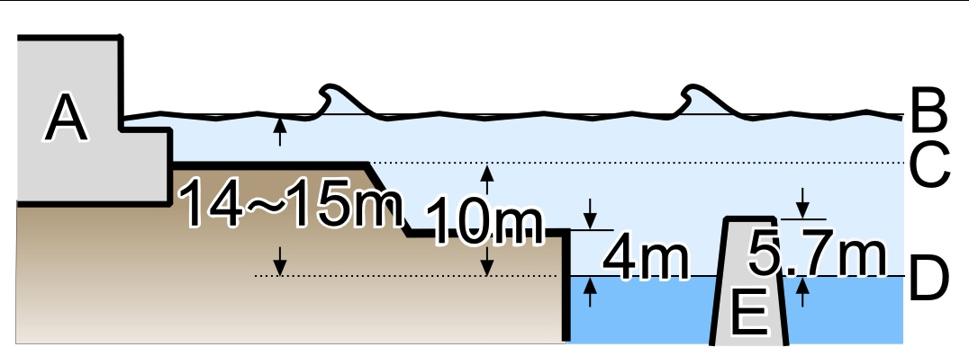

Fig. 2. The height of the tsunami [7]

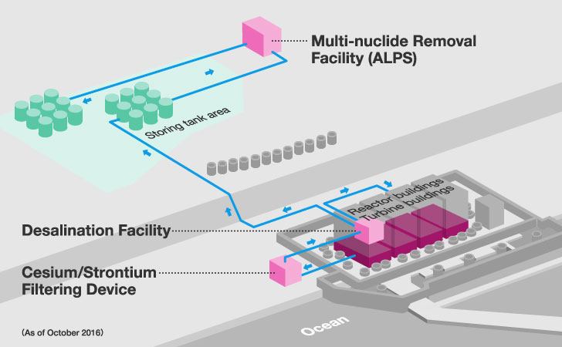

Fig. 3. ALPS Water Treatment Facilities [8]

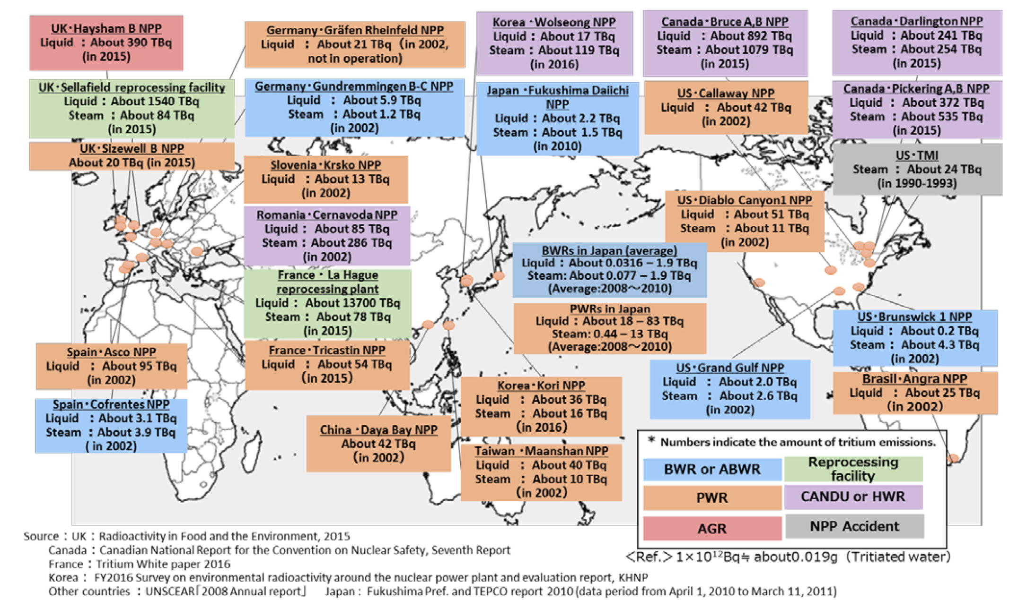

Fig. 4. Annual release of tritium from nuclear facilities in the world.

The ALPS stored 856TBq of the tritium, in comparison, the average annual emission of one nuclear power plant in Japan is about 385 TBq, the average annual emission of one nuclear power plant around the world is about 1,300 TBq through liquor of vapor, and the amount of naturally generated by cosmic rays is 70,000 TBq.
Tritium exists naturally in the tap water and all natural water bodies. The average amount of tritium in the tap water is 1[Bq/liter]. It also exists in human bodies naturally with the amount of tens of Bq.
The biological impact of tritium has not shown to be greater than other radiation or nuclei. Mouse carcinogenicity experiments showed that when the dose rate is 3.6 mGy/day (Tritium concentration in drinkable water: about 140 MBq/L) or lower, occurrence probability and quality are about the same as those due to natural cancer occurrence. Therefore, if the treated water met the regulation of the International Commis- sion on Radiological Protection (ICRP), the treated water will not affect human bodies. Committed effective doses specified by the International Commission on Radiological Protection (ICRP) recommendations is that the tritium concentration in drinkable water contains 1.810−8mSv/Bq, and the organically bound tritium contains 4.210−8mSv/Bq. TEPCO claimed that the successfully treat water had met this standard.

V. DISPOSAL PATH

Other than discharge the treated water into the sea, there are a few options that TEPCO had considered including geoshpere injection, underground burial, and vapor hydrogen release. [11] For geoshpere injection is limited by the type of ground, and the follow up monitoring technology is not clearly established. For underground burial, to solidified the contaminant water will generate tritium-included vapor, and new regulations are needed to be established. These problem is difficult to be fully solve in the limited time before the tanks filled up. Thus, the feasible options were limited to vapor or liquor release. Both of these two methods had had built regulation guild lines and been preceded for years.
The method of vapor releasing was normally preformed during ventilation under a controlled manner. The advantage of vapor releasing is that some of the radioactive nuclei in the treated water would remain dried residue and stay in the plants. Thus, the number of radioactive matter releasing into the environment will be reduced. However, the remaining residue are still nuclear waste that need further treatment. Furthermore, the quantity and characteristic of ALPS treated water is different with the previous vapor releasing. Regarding after the release, the vapor will be re-evaporated into the air after falling onto the land. Therefore, it is difficult to forecast and monitor the behavior of the released vapor. Also, the climate conditions such as wind and rain will carry the vapor further and wider causing more difficulty for monitoring.
For the reasons above, discharging into the sea is the feasible option that causes minimum negative effect. Also, there is discharge record and standard regarding the release into the ocean. The standard value for discharge tritium was 22[TBq/year] before the accident. TEPCO has knowledge on the design and operation of the sea water discharge system. However, the concentration of tritium in the discharged water will not be the same as the previous experience.
The follow up monitoring of discharging into the sea is easier than vapor release, because the variation of ocean current is much smaller than the climate conditions. Thus, it is easier to predict and set up oversight system for monitoring the influence of the action.

VI. CONCLUSION

Although nuclear energy is a much cleaner way to generate electricity, the damage it could cause is fatal and irrevoca- ble when accident happened. The Japanese government and TEPCO did tried to control and minimized the impact of the disaster. Resent research shows that the environment has recover from the accident. The radiation impact on wildlife and plants were under the standard, as shown in Table 1. [9] Also, the radiation impacts of the treated water will only be one-thousandth of the natural radiation exposure. However, the decision of discharging this water into the ocean is still concerning. 73% of the water didn’t meet the standard of releasing and there is no prove that a second treatment will succeed to lower the level of contamination to below the regulation. In addition, while the tritium levels do not threaten human health, the isotope could bind to other molecules and move up the food chain affection plants and other living creature including human. [12] If this contaminated water is discharged into the sea, it will be violating the international maritime law regardless the Japanese government approval.

TABLE I MONITORING RESULTS OF FOODS FROM FUKUSHIMA.

Type of food | Number of tests | Ratio exceed standard
Brown rice | All package | 0%
Vegetables and fruits | 386 | 0%
Livestock | 667 | 0%
Products Cultivated vegetables and mushrooms | 188 | 0%
Sea food | 859 | 0%
Inland water cultivated fish | 14 | 0%
Wild vegetables and mushrooms | 416 | 0%
Fish from river and lake | 232 | 2%

REFERENCES

[1] CNBC, “Japan plans to release treated radioactive water from fukushima into the sea in 2 years.” [Online]. Available: v https://www.cnbc.com/2021/04/13/japan-to-release-water-from-fukushima-nuclear-plant-into-sea-in-2-years.html
[2] “The japanese government’s fukushima contaminated water and international maritime law” Online]. Available: https://www.greenpeace.org/international/press-release/47207/the-japanese-governments-decision-discharge-fukushima-contaminated-water-ignores-human-rights-and-international-maritime-law/
[3] “Japan floods: After typhoon, rivers overflow, nuclear water.” [Online]. Available: https://www.bangkokpost.com/learning/advanced/688236/japan-floods-after-typhoon-rivers-overflow-nuclear-water
[4] “Japan: partial meltdown likely at 2nd reactor.” [Online]. Available: https://www.oklahoman.com/article/3548410/japan-says-partial-meltdown-likely-at-2nd-reactor
[5] “Fukushimainpp1975mediumcrop.” [Online]. Available: https://upload.wikimedia.org/wikipedia/commons/3/39/FukushimaINuclearPowerplantsiteclose- up28wotext29.PNG
[6] M. Ragheb, “Fukushima earthquake and tsunami station blackout accident.” [Online]. Available: https://ragheb.co
[7] “The height of the tsunami that struck the station.” [Online]. Available: https://commons.wikimedia.org/wiki/File:Fukushima_I_Powerplant_(Tsunami_height).png
[8] “Contaminated water treatment.” [Online]. Available: https://www.tepco.co.jp/en/decommision/planaction/alps/index-e.html
[9] “The subcommittee on handling of the alps treated water report.” [Online]. Available: https://www.meti.go.jp/english/earthquake/nuclear/decommissioning/pdf/20200210_alps.pdf
[10] “Alps treated water.” [Online]. Available: https://www.meti.go.jp/english/earthquake/nuclear/decommissioning/qa.html
[11] “Tritiated water task force report.” [Online]. Available: https://www.meti.go.jp/english/earthquake/nuclear/decommissioning/pdf/20160915_01a.pdf
[12] “Un experts deeply disappointed by decision to discharge fukushima water.” [Online]. Available: https://news.un.org/en/story/2021/04/1089852

