Feasibility of 100% Electric Vehicles in Illinois Powered by Renewable Energy Sources Only.
Sonia Chandra
Schand58@illinois.edu
NPRE 498
Spring 2021

Abstract
“Destination: Zero Carbon” was initiated by Environment America as a nationwide campaign to electrify vehicles in the US by 2035. While California has been the only state to outline a clear path to selling zero-emission vehicles only by 2035 through a mandate, the organization is urging other states to adopt similar laws. As these initiatives expand the market for electric vehicles (EV), there will be a large shift in the energy market as reliance on petroleum will significantly drop while reliance on renewable energy sources increases. I will be analyzing the feasibility of powering 100% of electric vehicles using renewable sources only in Illinois and what tradeoff the state will face with this shift. I will be using figures of anticipated renewable energy generation in 2035 to analyze the feasibility of this initiative. I will also take into consideration the costs of additional infrastructure that would need to be introduced such as charging stations and additional incentives that could be added to assist the public with this transition.

Introduction
The state of Illinois is currently the 5th largest energy-consuming state and 6th largest petroleum-consuming state in the nation. About 25% of the state’s energy consumption needs are the transportation sector. On average, the transportation sector consumes about 1014 trillion BTU a year. The state spends about $21,260 million annually on this sector.
Like many other states, Illinois has a Renewable Portfolio Standard (RPS) that require a specified percentage of the electricity that utilities sell comes from renewable resources. The portfolio was established in 2001 as a voluntary target but become an official standard in 2007. Below are the main targets of the RPS:
- 25% of electricity sold by utilities are from renewable sources by 2025.
- 40% of electricity sold by utilities are from renewable sources by 2025 by 2030.
- REC procurement from 10 million by 2020 to 45 million by 2030 (50/50 split from solar and wind.)
- 1% of annual requirement beginning in 2015 for IOU
- Wind: 75% of annual requirement for IOUs, 60% of annual requirement for alternative retail electric suppliers.
- Photovoltaics: 6% of annual requirement beginning in 2015-2016.
While the state is not currently on track to achieve the closet goal of the RPS, which is 25% by 2025, legislature is being added to assist the state achieve this goal. If the state were able to electrify privately owned vehicles by 2035, this would certainly assist in accelerating the states RPS goals, given more than half of the transportation’s consumption is from motor gasoline.
Environment Illinois is one of the largest proponents for electrifying the transportation sector in Illinois. They are a publicly funded organization that is pushing for better legislation to make Illinois a healthier and greener state. Their main campaign outlining this goal the “Destination: Zero Carbon” with the following goals:
- Make all new cars electric by 2035.
- Make all buses electric by 2030.
- Double the number of people who travel on foot, bike or public transit by 2030.
The campaign is mirrored after the Zero Emission Vehicle (ZEV) program which has been mandated in Illinois. It is managed by the California Air Resources Board (CARB) and has already been adopted by 10 other states (Colorado, Connecticut, Maine, Maryland, Massachusetts, New Jersey, New York, Oregon, Rhode Island, and Vermont.)
The goal of the ZEV program is to ensure that automakers research, develop, and market EVs. The mandate requires that California only sell EVs by 2035. By directly requiring that automakers invest in clean technology, the ZEV program is considered one of the nation’s most forward-looking climate policies, and a driving force behind an expanding market with over 40 zero emission models available to the U.S. public in 2019.
The ZEV program makes a distinction between the 3 main types of EVs:
- Plug-in hybrid vehicles: combine a conventional gasoline-powered engine with a battery that can be recharged from the electrical grid.

- Battery electric vehicles: run entirely on electricity and can be recharged from the electricity grid.

- Hydrogen fuel cell vehicle: run on electricity produced from a fuel cell using hydrogen gas.

The ZEV program works assigning each automaker “ZEV credits.” Automakers are required to maintain ZEV credits equal to a set percentage of non-electric sales. Each car sold earns a number of credits based on the type of ZEV and its battery range. The credit requirements increase over time.

Examples of the difference in credits for types of EVs are the Tesla Model S, which boasts a range of more than 200 miles, is eligible for 3.3 credits, while the 84-mile range Nissan Leaf is credited at 1.8 ZEV credits per car sold.

There are also limitations to they type of EVs for the program. Only 43% can come from plug-in hybrid vehicles given they are considered a transitional EV that still relies on gasoline. 57% of credits must come from battery EVs and fuel cell EVs.

Objectives
- Calculate total energy demand for 100% electric vehicles in Illinois by 2035.
For my analysis, I will only be focusing on the first goal of this campaign “Destination: Zero Carbon”, which focuses on privately owned vehicles and no public transport. While the California mandate only requires that all private vehicles that are being sold be EVs by 2035, this paper will investigate of all private vehicles being transitioned to EVs by 2035.

- Maximize use of renewable sources for powering EV’s.
I will be looking at expected generation values for 3 renewable sources: nuclear, wind and solar energy. The additional energy generated between 2020 and 2035 for the 3 sources will be compared to the energy demand needed for 100% EVs. I will BAU (Business as Usual) values, meaning I will not anticipate additional growth or funding for renewable energy unless projects have already been approved, are in progress, or have been outlined to grow to a certain value by 2035.

- Ensure Illinois grid capacity can handle additional energy demand.
Using net generation values in Illinois and total retail sales of electricity in Illinois, I will determine if the current grid system can supply and transmit the total energy demand for 100% EV’s.

- Determine if savings from crude oil can fund installation of charging infrastructure.
I will determine if the savings from petroleum will be able to fund the installation of charging infrastructure. I will assume that since 80% of gasoline stations will be converted into charging infrastructures with four charging ports at each location. Given a portion of the EVs in Illinois by 2035 will include plug-in hybrids, I am assuming about 20% of the current gasoline stations will be able to supply the states motor gasoline demands in 2035.

Equations
- Average Miles Travelled/Year x IL = Average miles per fuel consumption x Volume of gasoline consumed annually
- Total Energy Demand = Average Miles Travelled/Year x Average EV Energy Consumption
- Energy Savings = Energy Demand (100% ICE) – Energy Demand (100%EV’s)
- Feasibility on Illinois Grid System:
Net Energy Generated- Energy Consumed (Total Retail Sales)> Total Energy Demand
- Expected Renewable Energy Generated (Nuclear + Wind + Solar)> Total Energy Demand
- Annual Cost of Petroleum in Illinois > Cost of converting 0.8 current fuel stations to EV charging stations with 2 charging ports

Total Miles Driven in Illinois
Average car (ICE) fuel consumption = 25mpg
Illinois motor gasoline consumption (2019) = 105 720 000 Barrels
Gallons/Barrel conversion = 1 barrel/42 gallons
Total miles travelled in IL/ year (2019) = 25mpg x 105,270,000 Barrels x 42gallons/barrel
=1.1 x10^11 miles
(This value matches up with what I found from [5], total miles driven in Illinois in 2019 was 107 billion miles. I will use the value calculated above (110 billion miles). I will assume this value to be the total average miles driven per year, as I found the value fluctuates annually, but shows no trend in increasing or decreasing over the past decade.
Current Percentage of EV’s in Illinois
Registered Automobiles in Illinois in 2019 = 4,286,622
EV’s registered in Illinois (end of 2018) = 12400
Non EV cars in Illinois = 4,274,222
Percentage of EV’s in Illinois = 0.3%
Currently, only about 0.3% of cars in Illinois are EV’s. To simplify calculations, I will assume that we are starting from 0% EV’s since the difference in energy needed will be insignificant.
Total Energy Demand (100% EVs)
Average EV energy consumption =314Wh/mile
Total Energy Demand (100%) = 1.1 x 10^11 miles x 314Wh/mile
=3.454x10^13 Wh
=34.54 TWh
=About 35 TWh
Difference in Energy Demand between 100% ICE Vehicles and 100% EV’s
Barrel of oil energy conversion = 5.8 million BTU/ Barrel of oil
Current Energy Demand (Petroleum) = 105 720 000 x 5.8 mil BTU
= 179.65 TWh
Energy saved from oil to electricity = (179.65-34.54)/179.65 = 80%

Feasibility on Illinois Grid System
Current net electricity generation = 184TWh
Total Retail Sales = 138TWh
Energy not consumed = 46TWh
Additional energy needed = 34.54 TWH
The difference between the net electricity generated and energy sold (consumed) is larger than the energy demand for (100%) EV’s. Thus, the current grid system already has the capacity to supply and transmit the total energy demand.
Anticipated Renewable Energy Generation in 2035
Using values of current renewable energy generated (nuclear, wind and utility-scale solar) from the past 20 years, I was able to extrapolate to find anticipated generation values in 2035. These values follow the assumption that the 3 sources will grow at the continued same rate in the next 15 years. While this may not be the case for nuclear energy, the overall value is still a conservative estimate given Illinois Renewable Portfolio Standard aims to power the state with 25% of renewable energy by 2035 and 40% by 2030. Thus, wind and solar will realistically grow to much larger values than shown in table 1.
Table 1: Anticipated Energy Generation Values for Nuclear, Wind and Utility-Scale Solar by 2035 (in Thousand MWh)
Source | Nuclear | Wind | Solar | Total
Current Generation (2020) | 100246 | 17111 | 92.85
Expected Generation (2035) | 105356 | 86486 | 185.5
Additional Energy | 5110 | 69375 | 92.65 | 74577.65

The overall sum of additional energy generated from 2020-2035 is 74577 thousand MWh (74 TWh). This value is more than double the total energy demand for 100% EV’s which is 34 TWh.
Cost of Infrastructure for Electric Vehicle Supply Equipment (EVSE)
Average installation cost = $4200
Average cost of public lvl 2EVSE unit =$4500
Annual electricity cost =$686/yr
Total cost =$9386
Current motor gasoline stations =3,816
Electric stations =843
Assume we need to add 1 public charging port to 80% of gasoline stations by 2035:
Number of stations by 2035 that need 1 EVSE =0.8(3816)
=3053
Cost of adding 3053 EVSE ports =3053 * $9386
=2 999 980 (about $3Million)
Price of petroleum in IL =$43.96 / barrel
Cost of petroleum/year = $43.96 x 105 720 000 barrels
= $4.6 Billion
Cost of commercial electricity =8.63 cents/kWh
Cost of EV (assuming all cars charged using public EVSE) = 34.54 TWh x 10^9 x 8.63 cents/kWh
=$ 2.98 Billion/year
Savings from ICE vehicles to EV’s = $4.6 Billion - $2.98 Billion
=$1.62 Billion
Cost of infrastructure/savings =4* $3 Million/$1.62 Billion
=0.074 = 7.4%
Just from the figure of how much of savings per year, we can see that the cost of infrastructure is only 7.4% of the saving per year. Thus, the needed infrastructure can be built in Illinois by 2035. However, building EVSE will not be the only infrastructure needed by 2035. The state will also require additional incentive programs to assist the public with this program. Below are some current incentives that already exist in Illinois for EV owners.
- EV exemption from state emissions testing.
- ComEd offers 3 EV rate plans for residential customers.
- Illinois Electric Co-op members may be eligible to finance their EV at 0.5% interest.
- City of Naperville offers $30 per kW up to $3,000 (filed on behalf of customer).
To meet the goal of 100% EVs by 2035 or even a portion of that goal, larger subsidies and rebates need to be implemented to help low-income communities access EVs as owning and powering EVs requires a large upfront cost. Given the cost of building EVSE only requires less than 10% of the savings from gasoline expenditure, the remaining funds should be allocated towards reducing the cost of purchasing and owning an EV.
Results
The goal of Illinois operating with 100% EV’s is very much feasible given the analysis I have run above. The additional demand of 34.54TWh can be powered by the 184TWh net generation in the state. The grid system in Illinois also has the capacity to run the additional energy demand if needed. Using BAU standards, we see that just from nuclear, wind and solar, the additional energy generated is 72TWh. This is more than double the total energy demand. The cost of building infrastructure is only 7.4% of the total savings to the entire state from switching to EVs. Thus, the state should have the capacity to build the needed infrastructure over the next 15 years. However, the state would also need to implement better incentives to help the public transition to EVs.
Appendix
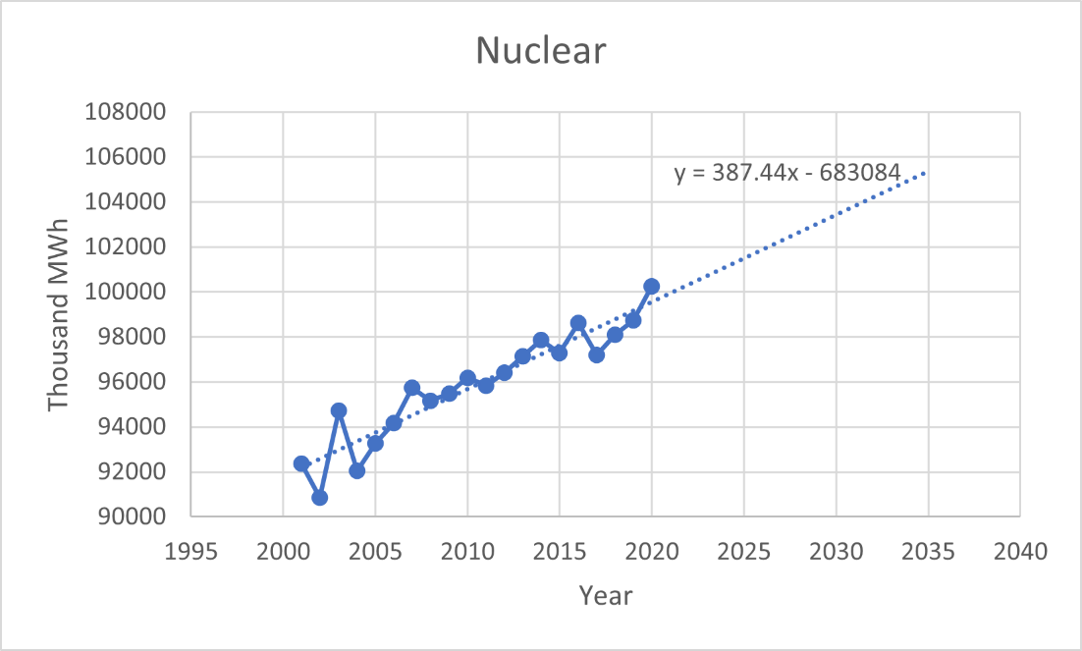
Figure 1: Nuclear Energy Generation Values in Illinois Extrapolated to 2035
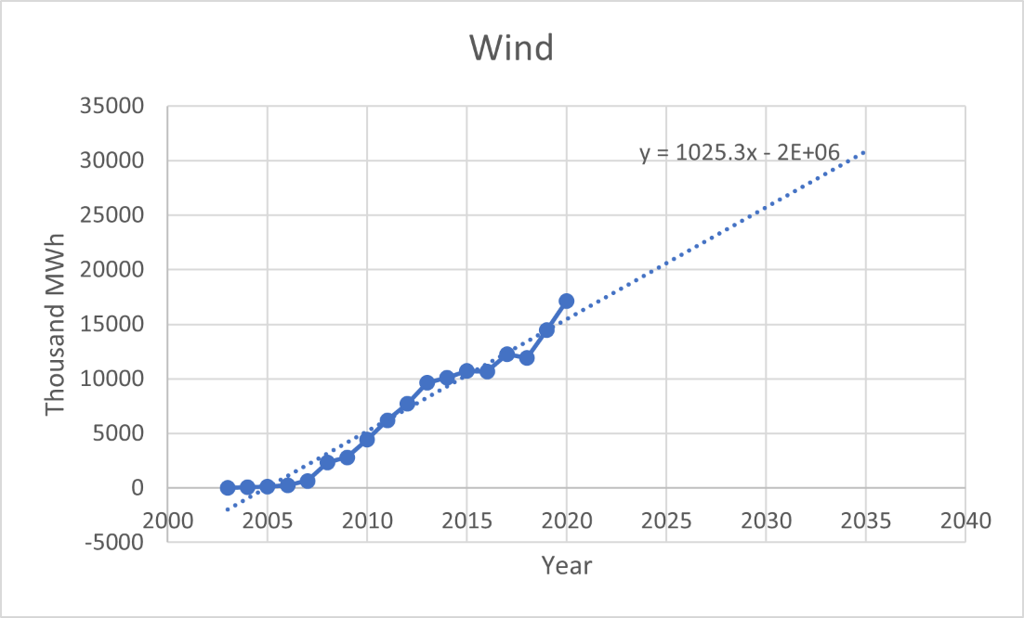
Figure 2: Wind Energy Generation Values in Illinois Extrapolated to 2035

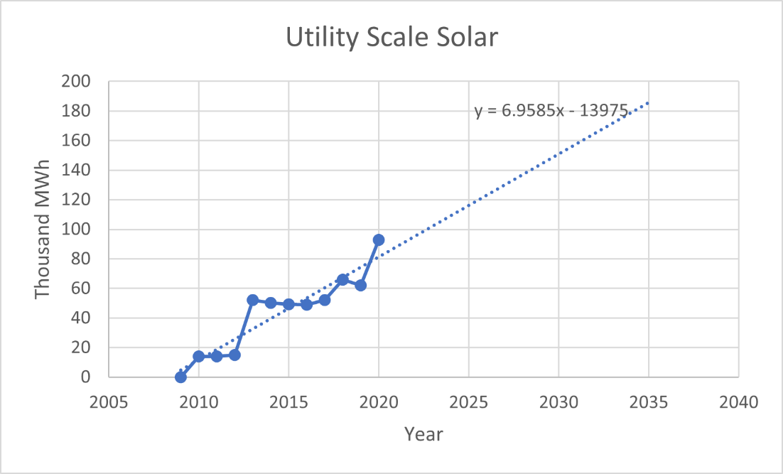
Figure 3: Utility Scale Solar Energy Generation Values in Illinois Extrapolated to 2035

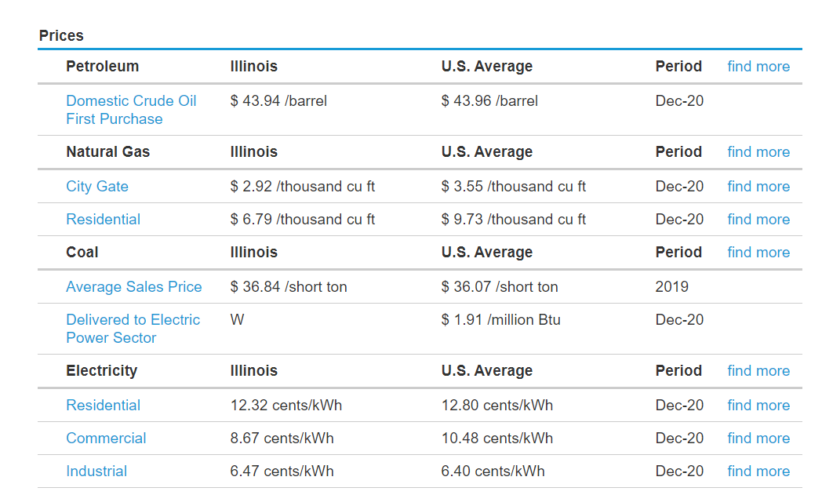
Figure 4: Current Prices of Different Energy Sources in Illinois

References
https://ev-database.org/cheatsheet/energy-consumption-electric-car
https://www.iea.org/reports/fuel-consumption-of-cars-and-vans
https://www.epa.gov/automotive-trends/highlights-automotive-trends-report
https://afdc.energy.gov/data/10962
https://www.thezebra.com/resources/driving/average-miles-driven-per-year/#average-miles-driven-per-year-by-state
https://www.valuepenguin.com/auto-insurance/car-ownership-statistics
https://www.solarpowerworldonline.com/2019/06/illinois-agency-says-state-wont-reach-rps-of-25-by-2025-unless-legislation-changes/
https://ilenviro.org/energy/renewable-energy/
https://afdc.energy.gov/files/u/publication/evse_cost_report_2015.pdf
https://www.ucsusa.org/resources/what-zev
https://www.tesla.com/support/incentives#Illinois

